LAB 8

Group 14

Khoo Jie Xuan

Putera Syabil

Pharveish Ail Selvam

EXERCISE 1

QUESTION 1

A) 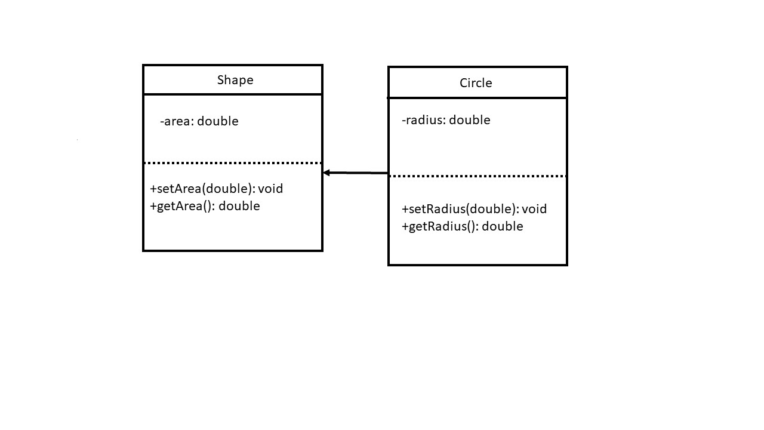

B) Public members of Circle : setRadius(double), getRadius(), setArea(double), getArea()

C) Private member of Shape, area.

D)

|  |  |
| --- | --- |
| c.setRadius(10.0) | Legal |
| s.setRadius(10.0) | Illegal |
| cout<<c.getArea() | Legal |
| cout<<s.getArea() | Legal |

QUESTION 2

A) this -> width = width;

this -> length = length;

B) : public Rectangle

C) Square(double, double, double)

D) Square(double width, double length, double height)

:Rectangle(width, length)

E) calculateArea()*height

F) cout<<Rectangle::display()

G) Square squareBox(15,10,10)

H) double volume = squareBox.calculateVolume();

I) squareBox.display();

QUESTION 3

|  |  |
| --- | --- |
| Member Variable | Access Specification in Words Class |
| name | Inaccessible |
| page | Protected |
| publisher | Protected |
| numWords | Inaccessible |
| meaning | Protected |
| words | Public |
| perkataan | Protected |
| num | Private |
| source | Public |

QUESTION 4

A)

i)

Automobile object: BMW makes in 2010. The price is RM 150000.00.

Car with car’s make, year model and price (“BMW”, 2010, 150000.0) accordingly.

II)

Automobile object: Toyota makes in 2014. The price is RM 45000.00.

Toyota’s car has 4 doors.

This is the truck with 4WD drive type.

iii)

An automobile object has been created but not yet have details.

B)

|  |  |  |  |  |  |
| --- | --- | --- | --- | --- | --- |
| Object | Make | Model | Price | Doors | Drivetype |
| Car | Own | Own | Own | Own | No |
| Truck | Own | Own | Own | Own | Own |
| Automobile | Own | Own | Own | No | No |

C)

|  |  |  |  |  |  |
| --- | --- | --- | --- | --- | --- |
| Object | Make | Model | Price | Doors | Drivetype |
| printInfo() | Accessible | Accessible | Accessible | No | No |
| printCar() | No | Accessible | Accessible | Accessible | No |
| printTruck() | No | Accessible | Accessible | No | Accessible |
| automobile | No | No | Accessible | No | No |

QUESTION 5

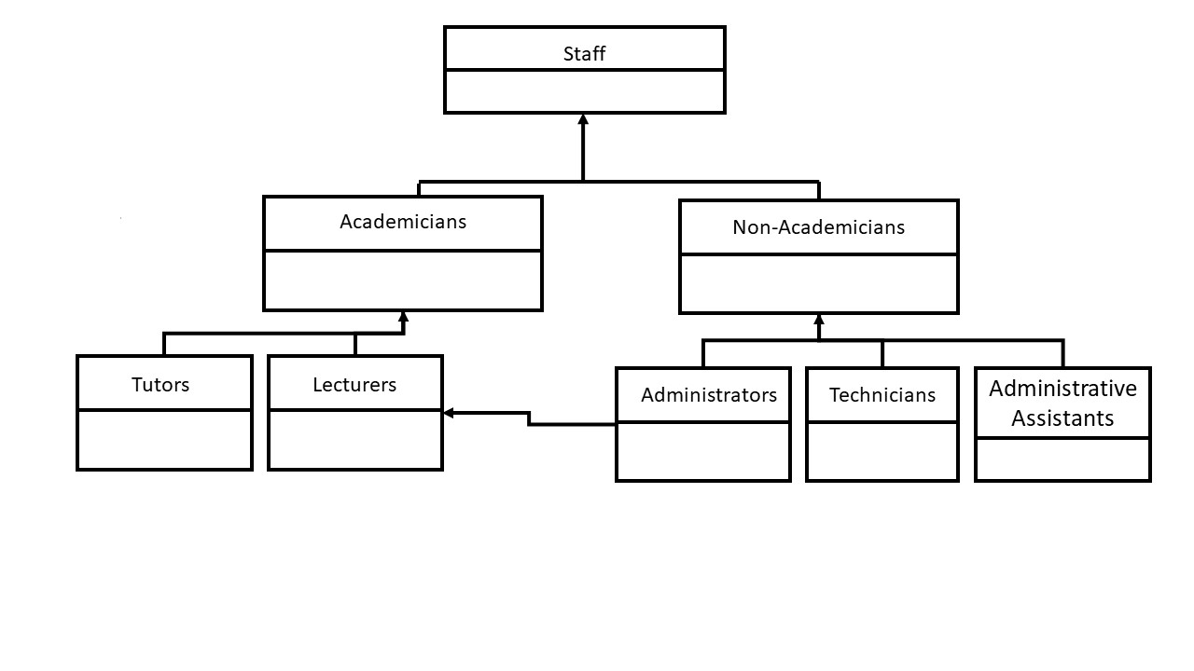

EXERCISE 2

QUESTION 1

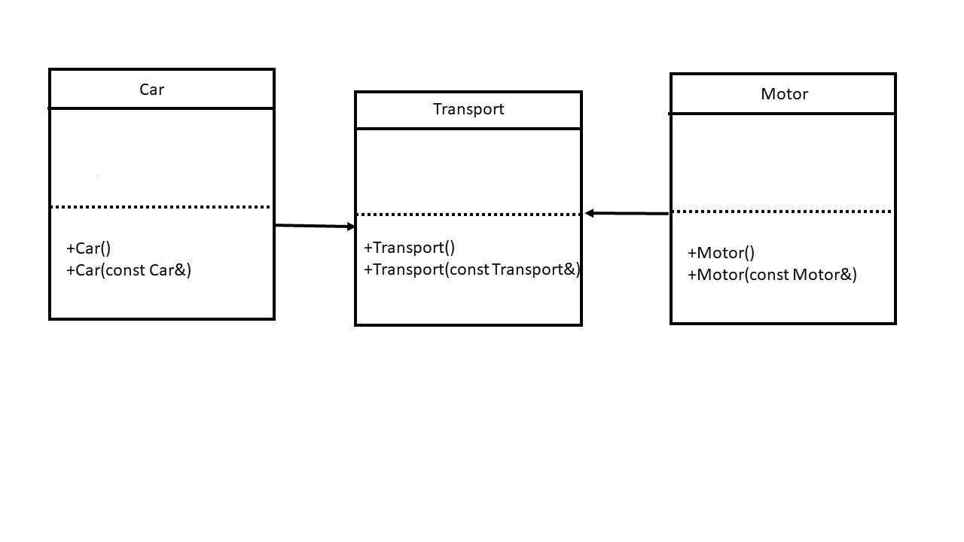

When the object of Car is invoked, it will first invoke the default constructor of the superclass Transport. Therefore, it will print out the statement in the default constructor of the class of Transport first and then print the statement in the constructor of Car. The same process happens when the object of Motor is invoked.

Then the object of Transport is invoked with the copy constructor. Therefore it print out the statement in the copy constructor.

QUESTION 2

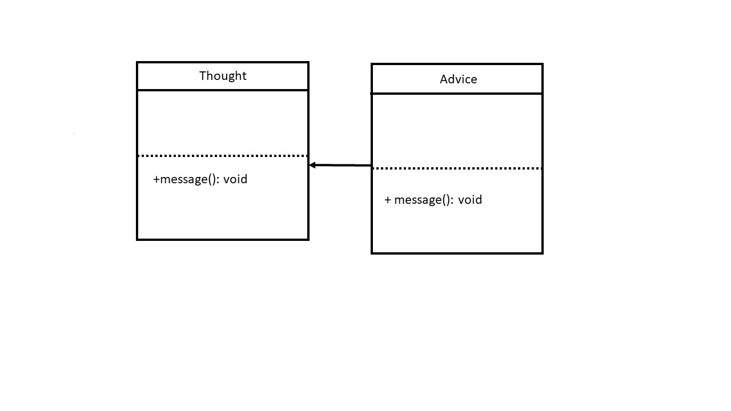

The objects of Thought and Advice are created and then the following statements has call the function message of these two objects respectively. Therefore, it prints out the statement in the two different functions respectively.

The objects of Thought and Advice are created just like the previous one. However, the function message of Advice has a statement which called the function message of Thought class. Therefore, the output will print out the statement of message of class Thought twice and then the statement of the message of Advice class.

QUESTION 3

A)

void showValue( int a ) = method overriding

void showValue( double a ) = method overloading

B)

The subclass: 8

8.97

C)

Overriding functions can be used when the class is inherited from other class while overloading can occur without inheritance.

QUESTION 4

A)

Line 57

Line 30

B)

Line 57: It is protected. So it can only be accessed in the class.

Line 30: It invoke the class of B but B does not have default argument. Thus, it cannot be compile.

C)

Redefine the function void changeValue( int ) to public member

public:

void changeValue(int);

Redefine the constructor of class B

B(){ }

Output:

i : 25 j : 45 k : 0

j : 10

QUESTION 5

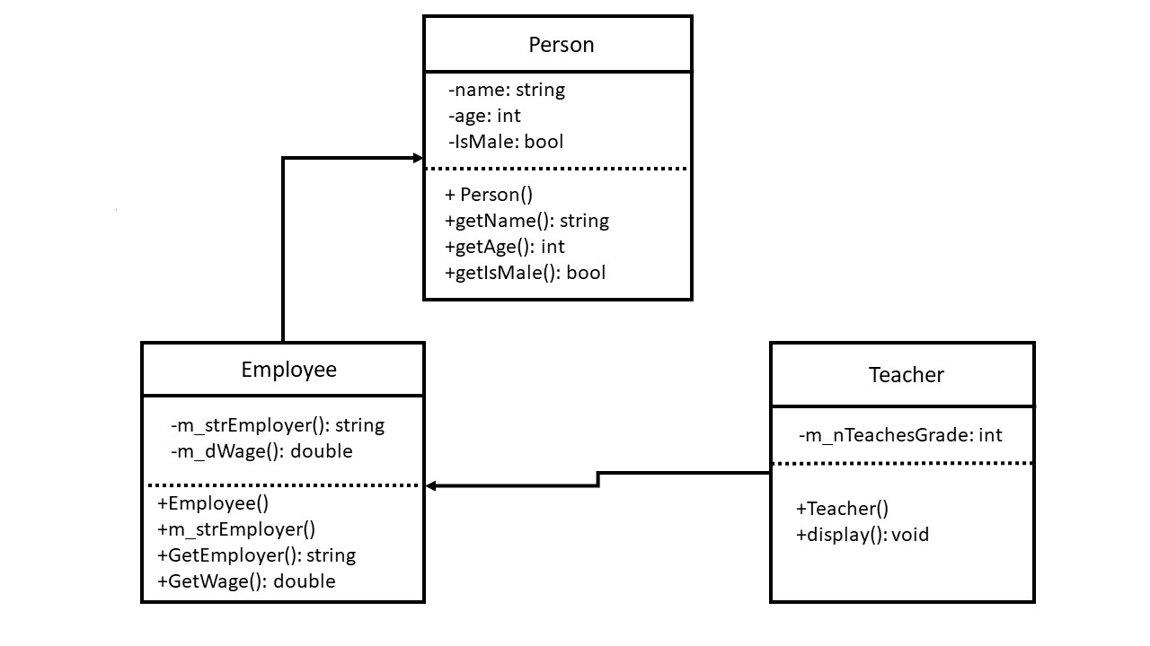

The object of Teacher is created with the arguments. Those arguments are pass into the constructor of the Teacher. The initializer list of the constructor of Teacher is then pass those arguments into the class’s constructors. It call the function of display and print out those statements.